- Last night marked the finale of The Amazing Race – Season 17. Below marks the journey taken by the teams. Using the map of the race, plot their course using a ruler and record their bearing in the table below.

Leg of Race | Country: | Bearing from True North
1 2 | USA England
2 3 | England Ghana
3 4 | Ghana Sweden
4 5 | Sweden Norway
5 6 | Norway Russia
6 7 | Russia Oman
7 8 | Oman Pakistan
8 9 | Pakistan Hong Kong
9 10 | Hong Kong South Korea
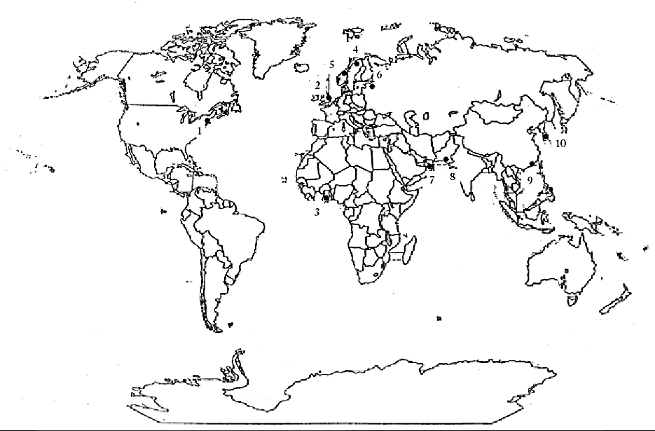

- Looking at your map:
  - What is the angle between USA:England:Ghana

  - Is this an acute, obtuse or a reflex angle?

  - For this angle, which country would be considered the vertex?

- Looking at your map:
  - What is the angle between Pakistan:Hong Kong: South Korea

  - Is this an acute, obtuse or reflex angle?

  - For this angle, which country would be considered the vertex?

- What angle is supplementary to 105°?

- What angle is complementary to 65°?

- Does 105° have a complementary angle? Explain.

- Use your knowledge of parallel lines cut by a transversal to determine the measurements of the unknown angles.
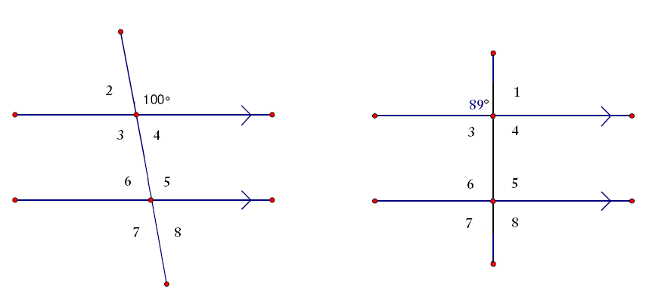
Angle | Measurement | Angle | Measurement
1 | 100° | 1
2 |  | 2 | 89°
3 |  | 3
4 |  | 4
5 |  | 5
6 |  | 6
7 |  | 7
8 |  | 8

- Bisect this circle into 12 equal pieces.
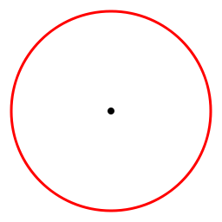

- Consider the following lattice tower. If the two highlighted cross braces are the main line segments and the right side of the tower is the transversal, which pair of numbered angles are corresponding angles?
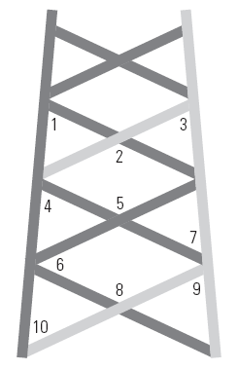

- The slanted outer beams of an A-frame building form a 72° angle with the ground floor. What must the angle between these beams and the joists support the second floor be if the second floor is to be horizontal like the ground floor?
